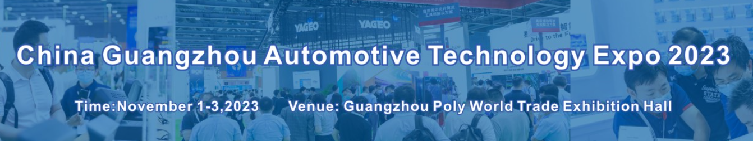

Dear distinguished visitors,

Welcome to visit the 10th China Guangzhou Automotive Technology Expo 2023.

The 10th China Guangzhou Automotive Technology Expo 2023 (AUTO TECH) will be held from November 1-3, 2023 at the Guangzhou Poly World Trade Center Exhibition Hall. And it covers all the important topics of automotive industry such as automotive electronics, connected car, EV&HV, power semiconductor, smart cockpit, lightweight, automotive test and autonomous driving etc, which will attract 500+ suppliers to showcase products and technologies representing the entire supply chain.

6 Reasons to Come to The China Guangzhou Automotive Technology Expo

When attending the China Guangzhou Automotive Technology Expo, you will have 6 advantages to set you apart in the industry such as the following:

● Access to source the latest technologies from 500+ suppliers across the automotive supply chain.

● Learn about the latest market innovations from across the industry.

● Gain new ideas for new trends of OEMs towards electrification, intelligence, connectivity, and shared mobility.

● Watch live product demos showcasing cutting-edge automotive technology.

● Join our social networking receptions to meet thousands of peers over drinks/bites who are committed to innovation.

● China's electric and intelligent car market is booming, a lot of opportunities gather here.

Finally, we sincerely wish you a pleasure travel to AUTO TECH 2023, and wish that you achieve desired results at the event.

Event Manager (Chinese/English)

Mr. Brian BAO

Mob：86-181 0257 5351

Tel：86-020 3439 7221

Email: brianbao@jswatsonexpo.com

|  |  |  |  |
| --- | --- | --- | --- |
| Company Name |  | | |
| Visitor Name | Phone | E-mail | Website |
|  |  |  |  |
|  |  |  |  |
|  |  |  |  |
|  |  |  |  |
|  |  |  |  |

Please mark the exhibits topics with √ in □ that you are interested with.

**1, Automotive Electronics**:

□Automotive Components & In-vehicle System,

□Semiconductors,

□Electronic Components & Devices,

□ECU Manufacturing & Testing Technology,

□In-vehicle Software Development,

□ADAS/Autonomous Driving Technology,

□EMC/Noise Reduction,

□Thermal Management Technology,

□Design Engineering & Development Solution ect, □

**2, EVs Power Electronics and Automotive LED**:

□IGBT/MOSFET,

□Gallium Nitride (GaN) and Silicon Carbide (SiC),

□Automotive LED Chip/Light Source

3**, Smart Cockpit**:

□Cockpit domain controller(CDC), Soc, MCU, GPU, NPU,

□ display,

□AR HUD, Ambient light, Operating system, Car stereo,

□Human-computer interaction system,

□car interior ect,

**4.EV/HV technologies:**

□Drive System,

□Rechargeable Batteries, Next-generation Batteries,

□Motor Technologies, Inverters, Peripherals, Chargers, Connectors, Harnesses ect,

**5, Autonomous Driving**:

□Sensors, Radars,

□AI/semiconductors, Dynamic maps,

□Testing Solutions, Security Solutions ect,

**6, Connected Car Technologies**:

□Communication Module, Human Machine Interface, In-Vehicle Operating System, Telematics Service.

**7, Lightweight Technologies**：

□Materials, Molding / Processing Technologies, Processing Equipment, Components

□Modules, Dissimilar Material Joining Technology, Other Technologies for Automotive Weight Reduction ect,

**8, Automotive Test**:

□Test simulation;

□NVH analysis,

□Engine/emissions testing,

□Materials testing,

□Vibration and shock testing,

□Acoustic testing, Environmental testing,

□ Automated test equipment (ATE),

□EMC/electrical interference testing, Software test,

□Component testing ,Tire testing ect.

□Other testing.

**If you are a foreigner and want to do Visitor Pre-registration, please fill out the form and send it back to Mr. Brian BAO [brianbao@jswatsonexpo.com](mailto:brianbao@jswatsonexpo.com), will get the confirmation soon.**

Event Manager (Chinese/English)

Mr. Brian BAO

Mob：86-181 0257 5351

Tel：86-020 3439 7221

Email: brianbao@jswatsonexpo.com

Event Website: www.china-autotech.com